SCHMEISER S–TINE SEEDER
2nd GENERATION – SERIES ’98

ASSEMBLY & PARTS
MANUAL

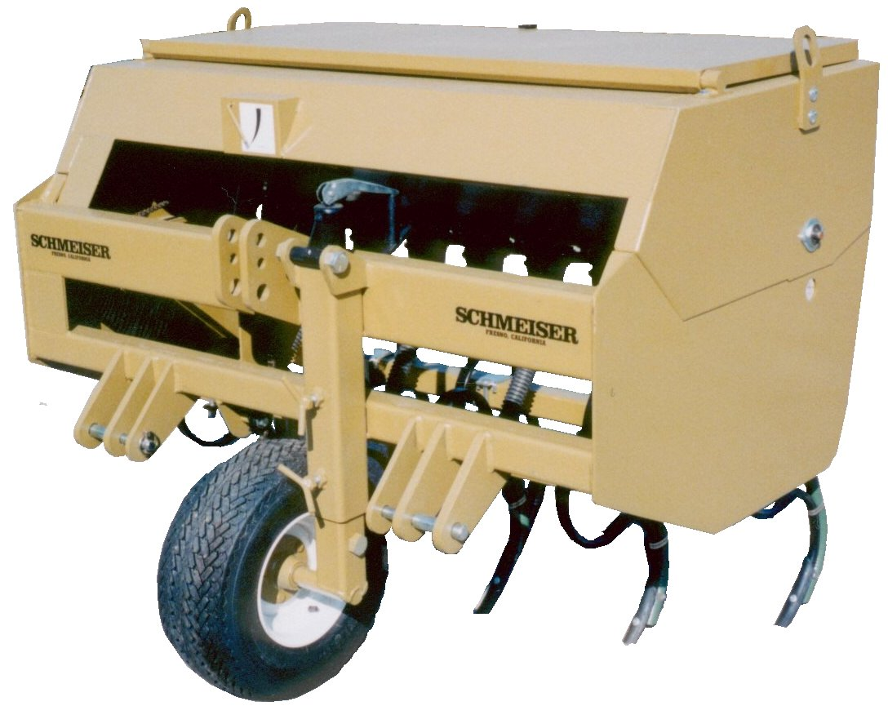

T.G. SCHMEISER CO., INC.
P.O. BOX 1112 FRESNO, CA 93714-1112
(559) 268 - 8128 FAX (559) 268 – 3279

VERSION 2.2

INTRODUCTION

Your Schmeiser S-Tine Seeder is designed to give you many years of dependable service. This manual has been prepared to instruct you in the safe and efficient operation of this machine. Read and study it thoroughly. Follow all instructions carefully.

Should your S-Tine Seeder require replacement parts, go to your Schmeiser dealer.
Always order genuine Schmeiser replacement parts.

It is important that you complete and send in your Warranty Card because it is not valid unless it is on file at Schmeiser. If you need information not contained in this manual, contact your Schmeiser dealer.

Space has been provided below for you to record the model number and serial number of your seeder. Be sure to bring this information with you to your dealer when ordering parts or attachments for your seeder.

Thank you for buying a Schmeiser S-Tine Seeder.

SERIAL NUMBER

MODEL NUMBER

DATE PURCHASED

DEALER NAME

Page 1.1

TABLE OF CONTENTS

Introduction.................................................................................................................1.1
Table of Contents........................................................................................................2.1
Safety Rules.................................................................................................................3.1
Seed Rate Calibration...........................................................................................…...4.1
Seed Rate Chart......................................................................................................….4.2
Seed Cup................................................................................................................…..5.1
Planting Depth Adjustments........................................................................................6.1
Sprocket and Chain Assemblies..............................................................................….7.1
S-Tine Seeder Box Assembly......................................................................................8.1
Feeder Cup and Drive Components.....................................................................….....9.1
Feeder Cup Assembly.......................................................................................…......10.1
Main Frame and Wheel Leg Assemblies.......................………………….…………11.1
Jack Shaft, Sprocket, Idler and Bearing Assemblies............................................…..12.1
S-Tine and Hose Assemblies………………………………………………………..13.1
Warranty.........................................................................................................……....14.1

Page 2.1

SAFETY RULES

The safe operation of any machinery is a big concern to farmers and manufacturers. We have designed our S-Tine Seeder with many built-in safety features. However, no one should operate this machine before carefully reading this Owner’s Manual.

1. Never permit anyone to ride on or walk beside the S-Tine Seeder when moving.

2. Never permit anyone to ride on tractor when S-Tine Seeder is being moved.

3. Never allow anyone to be near the S-Tine Seeder when performing operating functions with
seeder or tractor.

4. Never load S-Tine Seeder without being hooked-up to tractor.

5. Extra care should be taken when transporting with seed in the box.

6. Never back S-Tine Seeder up when s-tines are in ground.

7. Reduce speed of tractor when transporting over uneven or rough terrain. Avoid all
chuck holes and washboard areas in road.

8. Reduce speed of tractor when transporting over hills or steep slopes.

9. Always set S-Tine Seeder in field position before lubrication.

10. Do NOT lubricate, adjust or repair the S-Tine Seeder while it is in operation.

11. When in transport, use accessory lights and devices for adequate warning to operators
of other vehicles, and use safety chains. Comply with all Federal, State and local
laws when traveling on public roads.

12. Use “Slow Moving Vehicle” emblem for warning vehicles approaching from rear.

13. Do NOT permit smoking, sparks, or an open flame where combustible lubricants,
or liquids are being used.

14. When using treated grain, avoid direct contact with the seed.

15. When using compressed air to clean S-Tine Seeder, wear safety glasses.

16. When transporting, remember the S-Tine Seeder may be wider that your tractor and extreme
care must be taken to allow for safe clearance.

Page 3.1
SCHMEISER S-TINE SEEDER
SEED RATE CALIBRATION

Note: Seeding rates will vary greatly with variations in sizes of seeds. Although the seeding rates listed in this manual are based on an average seed size, we recommend that you test and adjust your S-Tine Seeder using the procedures listed below.

1) There are many factors, which will affect seeding rates: Seed treatment, weight of seed,
size of seed, surface condition of seed, tire configuration and pressure, and tire slippage.
Minor adjustments will probably be needed to compensate for the above factors.

2) The rates listed in the seed charts are based in the gauge wheel drive having 20.5 x 8.0
x 10 tire with the recommended tire inflation.

3) The large difference in seed size and treatment can cause a wide variation in actual
seeding rates. The rate charts are based on average size seed. This may differ from
the seed you are using. Use the seed rate charts as a guide only. Set the pounds per
planted acre desired at the indicator number and complete the following procedure to
calibrate the rate for specific seed.

a. Place several pounds of seed over three feeder cups at the outboard end of the
S-Tine Seeder.

b. Pull the seed tubes out of these three drops.

c. Raise the drive wheel off the ground using a jack.

d. Rotate the tire to see that the drive system is working properly and that the
feed cups are free from foreign matter.

e. Place a container under the three seed tubes to gather seed as it is metered.

f. On 4 ft. wide models rotate the tire 48 times to obtain 1,000 square feet. On 5 ft. wide models rotate the tire 38 times to obtain 1,000 square feet. On 6 ft.
models rotate the tire 32 times to obtain 1,000 square feet. Be sure to check the three
feeder cups to make sure each cup has plenty of seed coming into it.

g. Weigh the seed, which has been metered. Divide by three. This will give you the
ounces/pounds metered by each feeder cup. Multiply by the number of cups on your
S-Tine Seeder to arrive at the total pounds per 1,000 square feet. Now multiply by
43.56 to arrive at the total pounds per planted acre. If this figure is different than
desired, set your feed cup adjustment lever accordingly.

4) You may want to repeat the calibration procedure if the results of your calibration vary
greatly from the suggested settings contained in this manual.

REMEMBER: Tire size and field conditions will also affect seeding rates. Be certain that your S-Tine Seeder tires are 20.5 x 8.0 x 10 and that they have the proper inflation. When seeding, check the amount of seed you are using by noting area seeded, amount of seed added to box, and level of seed in seeder box. If you suspect that you are seeding more or less seed than desired, and you have accurately calibrated the S-Tine Seeder to your seed, you may need to adjust the seeding rate slightly to compensate for your field conditions.

Page 4.1

SEEDING RATES FOR SCHMEISER S-TINE SEEDER
2ND GENERATION – SERIES ’98

THIS CHART APPLIES TO S-TINE SEEDERS MANUFACTURED AFTER JANUARY 2001

NOTE: INSURE THAT SQUARE SEED CUP SHAFT IS WELL LUBRICATED WHERE SHAFT GOES THROUGH CUP DRIVE BEARING (SEE Page 9.2)

Page 4.2

PLANTING DEPTH ADJUSTMENT

Your Schmeiser S-Tine Seeder is designed to run level to the ground when in planting position. Minor adjustments may be required to achieve the desired seed placement. In order to adjust your gauge wheel/drive wheel, loosen the two set screws located on the adjusting crank housing. Rotate crank to achieve desired planting depth. After adjusting the gauge wheel/drive wheel, be certain to tighten up both set screws.

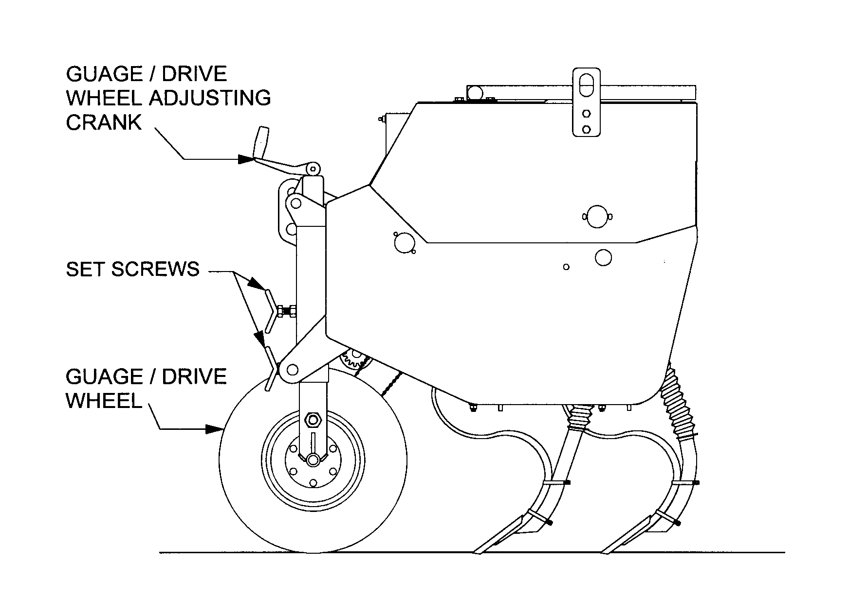

Page 6.1

S-TINE SEEDER BOX ASSEMBLY

Ref. No. | Old Part No. | New Part No. | Description
1. | VD4-C | VDS-48C000 | 4’ Vineyard Drill Lid Weldment
 | VD5-C | VDS-60C000 | 5’ Vineyard Drill Lid Weldment
 | VD6-C | VDS-72C000 | 6’ Vineyard Drill Lid Weldment
2. | ----------- | FWASHER-05 | Washer, Flat 5/16”
3. | ----------- | WWASHER-05 | Washer, Wave Spring 5/16”
4. | ----------- | NYNUT-05NC | Nut, Hex Nylock 5/16” - 18
5. | VD-C-07 | VDS-00C007 | Lid Latch-Handle
6. | 817-033D | 817-033D | Lid Latch Grip
7. | VD-M | VDS-00M000 | Lid Hinge Weldment
8. | VD-C-08 | VDS-00C008 | Lid Latch - Lower Arm
9. | ----------- | CSNC505016 | Bolt, Hex Head 5/16” - 18 x 1” Long Gr 5 Plated
10. | VD-C-12 | VDS-00C012 | Lid Latch – Lower Latch Bushing
11. | VD-C-09 | VDS-00C009 | Lid Latch - Upper Arm
12. | VD-L-02 | VDS-00L002 | Float Indicator – Shaft
13. | VD-L-01 | VDS-00L001 | Float Indicator Arm
14. | VD-L-04 | VDS-00L004 | Float Indicator - Coupling
15. | ----------- | CSNC506016 | Bolt, Hex Head 3/8” - 16 x 1” Long Gr 5 Plated
16. | VD-B-10 | VDS-00B010 | Sprocket Cover Plate
17. | VD4-B | VDS-48B000 | 4’ Seedbox
 | VD5-B | VDS-60B000 | 5’ Seedbox
 | VD6-B | VDS-72B000 | 6’ Seedbox
18. | ----------- | LWASHER#10S | Washer, Internal Star #10 Plated
19. | ----------- | HXNUT#10NC | Nut, Hex #10-24 Plated
20. | VD-C-10 | VDS-00C010 | Rear Lid Latch Hook
21. | ----------- | CSNC#10012R | Screw, Round Head #10-24 x 3/4” Long Plated
22. | ----------- | HXNUT-05NC | Nut, Hex 5/16” - 18 Gr 2 Plated
23. | ----------- | LWASHER-05 | Washer, Lock Spring 5/16” Plated
24. | ----------- | FWASHER-05 | Washer, Flat 5/16” Plated
25. | ----------- | HXNUT208NC | Nut, Hex 1/2” - 13 Gr 2 Plated
26. | ----------- | LWASHER-08 | Washer, Lock Spring 1/2” Plated
27. | ----------- | LWASHER-06 | Washer, Lock Spring 3/8” Plated
28. | ----------- | HXNUT506NC | Nut, Hex 3/8” - 16” Gr 5
29. | VD-B-09 | VDS-00B009 | Vineyard Drill Lift Hooks
30. | ----------- | CSNC508016 | Bolt, Hex Head 1/2” - 13 x 1” Long Gr 5
31. | ----------- | GBR-12FP03 | 3/4” Flangette Plates
32. | ----------- | GBR-12BI02 | Bearing 3/4” Bore with Collar
33. | ----------- | CSNC504024 | Bolt, Hex Head 1/4” - 20 x 1-1/2” Long Gr 5
34. | 202-002H | 202-002H | Sprocket, Speed Change 19T
35. | ----------- | HXNUTJ04NC | Hex Jam Nut 1/4” - 20 Plated
36. | ----------- | CBNC505012 | Bolt, Carriage 5/16” x ¾” Long Gr. 5
37. | VD4-G-09 | VDS-48G200 | 4’ Agitator Weldment
 | VD5-G-09 | VDS-60G200 | 5’ Agitator Weldment
 | VD6-G-09 | VDS-72G200 | 6’ Agitator Weldment
38. | ----------- | BALL-64OD | Float Indicator – Float
39. | VD-L-03 | VDS-00L100 | Float Indicator – Shaft Bracket – Weldment
40. | ----------- | GMB-CHFLIN | Float Indicator – Chain 10 ¾” Long
41. | ----------- | SHOOK-16 | S – Hook, 1”
42. | ----------- | LCOLLAR-05 | Lock Collar, 5/16”
43. | ----------- | FWASHER-06 | 3/8” Flat Washer
44. | ----------- | CSNC505024 | Bolt, Hex Head 5/16” x 1 ½”

Page 8.1

FEEDER CUP AND DRIVE COMPONENTS

Ref No. | Old Part No. | New Part No. | Description
1. | VD-B | VDS-48B000 | 4’ Box Weldment
 |  | VDS-60B000 | 5’ Box Weldment
 |  | VDS-72B000 | 6’ Box Weldment
2. | VD-K-01 | VDS-48K001 | 4’ Cup Tray
 |  | VDS-60K001 | 5’ Cup Tray
 |  | VDS-72K001 | 6’ Cup Tray
3. | VD-K-03 | VDS-00K003 | Pivot Handle Adjustment Mount
4. | VD-K-02 | VDS-00K100 | Seed Rate Adjustment Handle
5. | 109-025H | 109-025H | Adjustment Lock Plate
6. | VD-K-04 | VDS-00K004 | Gauge Mounting Plate
8. | VD-K-07 | VDS-SRINDP | Seed Rate Indicator Plate
9. | ----------- | CSNC#10008R | Screw, Round Head #10 x ½”
10. | ----------- | FWASHER#10 | Washer, Flat #10
11. | ----------- | LWASHER#10S | Washer, Internal Star #10
12. | ----------- | HXNUT#10NC | Nut, Hex #10
16. | ----------- | CSNC506016 | Bolt, Hex Head 3/8” - 16 x 3/4”Long
17. | ----------- | LWASHER-06 | Washer, Lock 3/8” Plated
18. | ----------- | FWASHER-06 | Washer, Flat 3/8” Plated
19. | 109-069D | 109-069D | Adjustment Handle Pivot Bushing
20. | ----------- | GPN-03X32C | Pin, Cotter 3/16” x 1-1/4” Long Plated
21. | 308-015D | 308-015D | Seed Adjustment Bearing Ring Pivot
22. | ----------- | 804-010C | Washer, Flat 5/16” USS Plated
23. | ----------- | NYNUT-05NC | Nut, Nylon Self Locking Hex 5/16” - 18
24. | ----------- | HXNUT-04NC | Nut, Hex 1/4” – 20
25. | ----------- | CBNC504012 | Bolt, Hex Carriage 1/4” - 20 x 3/4” Long
26. | ----------- | WGNUT-08NC | Nut, Wing 1/2” - 13 Plated
27. | ----------- | FWASHER-10 | Washer, Flat 5/8” Plated
28. | ----------- | FWASHER-08 | Washer, Flat 1/2“
29. | ----------- | CBNC508020 | Bolt, Hex Carriage 1/2” x 1-1/4”

Page 9.1

FEEDER CUP ASSEMBLY

Ref. No. | Part No. |  | Description
1. | VD4-K-01 | VDS-48K001 | 4’ Seed Cup Tray
 | VD5-K-01 | VDS-60K001 | 5’ Seed Cup Tray
 | VD6-K-01 | VDS-72K001 | 6’ Seed Cup Tray
2. | ------------ | CBNC504012 | Bolt, Carriage 1/4” - 20 x 3/4” Long
3. | 182-022D | 182-022D | Feeder Cup Shaft Locking Collar
4. | 801-035C | 801-035C | Screw, Set Knurled Point 5/16” - 18 x 3/8” Long
5. | ------------ | LWASHER-04 | Washer, Lock 1/4”
6. | 803-006C | HXNUT-04NC | Nut, Hex 1/4” - 20 Gr.5 Plated
7. | VD-K-07 | 118-438D | Spacer Tube 3-9/16” Long
8. | 308-004S | 308-004S | Sprocket Shaft Adjustment Bearing Assembly
9. | 890-190C | 890-190C | Powder Metal Sprocket
10. | 817-075C | 817-075C | Seed Cup Assembly
11. | 817-071C | 817-071C | Seed Cup Adjustment Handle
12. | 817-074C | 817-074C | Cup Sleeve
13. | 804-031C | 804-031C | Washer, Retaining
14. | 800-004C | 800-004C | Ring, Snap External 1-3/16”
15. | 800-107C | 800-107C | Ring, Snap Internal 2.165
16. | 822-103C | 822-103C | Bearing, 30mm B x 55mm OD
17. | 118-336D | 118-336D | Cup Drive Bearing Housing
18. | VD-K-07 | VDS-00K007 | Cup Drive Sprocket Weldment
19. | VD4-K-05 | VDS-48K005 | 4’ Seed Cup Shaft
 | VD5-K-05 | VDS-60K005 | 5’ Seed Cup Shaft
 | VD6-K-05 | VDS-72K005 | 6’ Seed Cup Shaft
20. | ------------ | CSNC506012 | Bolt, Hex Head 3/8” - 13 x 3/4” Gr.5
21. | ------------ | LWASHER-08 | Washer, Lock Spring 1/2” Plated
 | 176-031V | 176-031V | Cup Drive Housing Assembly
 |  |  | Includes 1 Each of Items 15 through 17

Page 10.1

MAIN FRAME & WHEEL LEG ASSEMBLIES

Ref No. | Old Part No. | New Part No. | Description | Qty.
1. | ST4-A | STS-48A000 | 4’ Main Frame | 1
 | ST5-A | STS-60A000 | 5’ Main Frame | 1
 | ST6-A | STS-72A000 | 6’ Main Frame | 1
2. | VD-J | VDS-00J000 | Jack Screw | 1
3. | VD-E | VDS-00E000 | Wheel Leg | 1
4. | VD-D | VDS-00D000 | Wheel Shaft | 1
5. | VD-F-01 | GPN-18CA12 | Clevis Pin Cat. I & II | 2
6. | VD-J-02 | VDS-00J100 | Set Screws | 2
7. | VD-G-10 | VDS-00G010 | Sprocket Key | 1
8. | VDB-01 | GSR-17112T | 7” Tension Spring | 1
9. | VDB-04 | GHB-5X4GSL | Oil Seal | 1
10. | VDB-05 | GHB-5X4BCN | Bearing Cone | 2
11. | VDB-06 | GHB-5X4BCP | Bearing Cup | 2
12. | VDB-07 | GHB-5X45VD | Hub, 5 Studs | 1
13. | VDB-08 | GSP-16VDCN | Castle Nut | 1
14. | VDB-09 | GHB-5X4CAP | Hub Cap | 1
15. | VDB-10 | GWT-801004 | 20.5 x 8 x 10 Tire with Wheel, 5 on 5 | 1
16. | VDB-12 | WHN-08NFWN | Lug Nuts | 5
17. | VDB-14 | GSK-12BS13 | 13 Tooth Sprocket | 1
18. |  | CSNC516088 | 1” x 5-1/2” Hex Head Gr 5 z/p Bolts | 1
19. |  | CSNC516064 | 1” x 4” Hex Head Gr 5 z/p Bolts | 1
20. |  | HXNUT-16NC | 1” Hex Nuts | 2
21. |  | GPN-04X24C | 1/4” x 1-1/2” Cotter Pin | 1
22. |  | GPN-070LYN | 7/16” x 1-3/4” Lynch Pins | 2

Page 11.1

JACK SHAFT, SPROCKET, IDLER & BEARING ASSEMBLIES

Ref No. | Old Part No. | New Part No. | Description | Qty.
1. | VD4-G-06 | VDS-48G006 | 4’ Jack Shaft | 1
 | VD5-G-06 | VDS-60G006 | 5’ Jack Shaft | 1
 | VD6-G-06 | VDS-72G006 | 6’ Jack Shaft | 1
2. | VD-G-02 | VDS-00G002 | End Plate Tensioner Arm | 1
3. | VD-G-01 | VDS-00G001 | Center Tensioner Arm & Spring Anchor | 1
4. | VD-G-03b | VDS-00G102 | Bushing, 13/16” Long | 2
5. | VD-G-03 | VDS-00G100 | Spring Anchor | 1
6. | VD-G-04 | VDS-00G004 | Bushing, 1/2” Long | 2
7. | VD-G-05 | VDS-00G005 | Bushing, 1-1/4” Long | 1
8. | VDB-01 | GSR-17112T | 7” Tension Spring | 1
9. | VDB-02 | GSR-10040T | 2-1/2” Tension Spring | 1
10. | VDB-33TS | GSK-12BS33 | 33 Tooth Sprocket | 1
11. | VDB-15I | GMB-15TIDL | 15 Tooth Idlers | 3
12. | VDB-12TS | GSK-12BS12 | 12 Tooth Sprocket | 1
13. | VDB-03 | GBR-12BI02 | Stamped Flange Bearing with Collar, 3/4” | 2
14. |  | CBNC505016 | 5/16” x 1” Carriage Square Neck Bolts | 4
15. |  | CSNC508032 | 1/2” x 2” Hex Head Gr 5 z/p Bolt | 1
16. |  | CSNC508040 | 1/2” x 2-1/2” Hex Head Gr 5 z/p Bolt | 2
17. |  | CSNC508056 | 1/2” x 3-1/2” Hex Head Gr 5 z/p Bolt | 2
18. |  | LWASHER-05 | 5/16” Lock Washers | 4
19. |  | LWASHER-08 | 1/2” Lock Washers | 3
20. |  | FWASHER-08 | 1/2” Flat Washer | 3
21. |  | HXNUT-05NC | 5/16” Hex Nuts | 4
22. |  | HXNUT-08NC | 1/2” Hex Nuts | 3
23. |  | NYNUT-08NC | 1/2” Nylon Locknuts | 2
24. | VD-G-10 | VDS-00G010 | Sprocket Key | 2
25. |  | GMB-40RCHN | #40 Roller Chain 63 1/2” Long | 1
26. |  | GMB-40RCML | #40 Roller Chain 54 1/2” Long | 1
27. |  |  | Set Screw, 3/16” | 2
28. | 118-226S | 118-226S | Feeder Cup Bearing Assembly | 1
29. |  | 202-002H | 19 Tooth Speed Change Sprocket | 1
30. |  | FWASHER-05 | 5/16” Flat Washer | 4

Page 12.1

S-TINE & HOSE ASSEMBLIES

Ref No. | Old Part No. |  | New Part No. | Description
1. | 800-009C |  | 800-009C | 1-5/8” Hose Clamp #26
2. | 816-028C |  | 816-028C | Seed Hose – 33 Ribs
3. | ST-BO-01 |  |  | 1-3/8” Hose Clamp
4. | ST-A-20 |  | GMB-HOSE16 | 1” Green Hose 16” Long
5. | ST-BO-02 |  | GMB-WGHC32 | Green Hose Clamps
6. | ------------ |  | CSNC508064 | ½” x 4” Hex Head Gr. 5 Bolt
7. | ------------ |  | LWASHER-08 | ½” Lockwasher
8. | ------------ |  | HXNUT-08NC | ½” Hex Nut
9. | ST-BO-03 |  | GST-2CL250 | 2-1/2” Tool Bar Clamp
10. | ST-BO-04 |  | GST-50125S | ½”x1-1/4” S-Tines
11. | ST-BO-05 |  | GST-25150P | S-Tine Points
12. | ST-BO-06 | } | GST-0624BN | Elliptical Head Bolt M10 x 38
13. | ST-BO-07 | } | GST-0624BN | Hex Nut For M10 x 38 Bolt

Page 13.1

T.G. SCHMEISER CO., INC.

LIMITED WARRANTY

T. G. Schmeiser Co., Inc. warrants each new Schmeiser product to be free from defects in material and workmanship. This warranty is applicable only for the normal service life expectancy of the product or components, not to exceed twelve (12) consecutive months from the date of delivery of the new Schmeiser product to the original purchaser.
Genuine T. G. Schmeiser Co., Inc. replacement parts and components will be warranted for 365 days from date of purchase, or the remainder of the original equipment warranty period, whichever is longer.
Under no circumstances will it cover any merchandise or components thereof, which, in the opinion of the company, has been subjected to misuse, unauthorized modifications, alteration, an accident or if repairs have been made with parts other than those obtainable through T. G. Schmeiser Co., Inc.
The Company in no way warrants engines, batteries, cylinders, tires or other trade accessories since these items are warranted separately by their respective manufacturer. Expendable components such as points, shanks, blades, rings, bearings, teeth, and the like are excluded from this warranty.
Our obligation under this warranty shall be limited to repairing or replacing, free of charge to the original purchaser, any part that, in our judgment, shall show evidence of such defect, provided further that such part shall be returned within thirty (30) days from date of failure to T. G. Schmeiser Co., Inc., routed through the dealer and distributor from whom the purchase was made, transportation charges prepaid.
This warranty shall not be interpreted to render T. G. Schmeiser Co., Inc. liable for injury or damages of any kind or nature to person or property. This warranty does not extend to the loss of crops, loss because of delay in harvesting, or any expense or loss incurred for labor, substitute machinery, rental or for any other reason.
Except as set forth above, T. G. Schmeiser Co., Inc. shall have no obligation or liability of any kind on account of any of its equipment and shall not be liable for special or consequential damages. T. G. Schmeiser Co., Inc. makes no other warranty, expressed or implied, and, specifically, T. G. Schmeiser Co., Inc. disclaims any implied warranty or merchantability or fitness for a particular purpose. Some states or provinces do not permit limitations or exclusions of implied warranties or incidental or consequential damages, so the limitations or exclusion in this warranty may not apply.
This warranty is subject to any existing conditions of supply, which may directly affect our ability to obtain materials or manufacture replacement parts.
T. G. Schmeiser Co., Inc. reserves the right to make improvements in design or changes in specifications at any time, without incurring any obligation to owners of units previously sold.
No one is authorized to alter, modify or enlarge this warranty nor the exclusion, limitations and reservations.

Page 14.1

